U18CO018

Shubham Shekhaliya

Sub: CN

Lab: Assignment 2

Topic : Socket Programming

• Perform Simple Socket Programming

Java Socket programming is used for communication between the applications running on different JRE(Client and Server).

Socket and ServerSocket classes are used for connection-oriented socket programming.

Client in socket programming must know two information:

1. IP Address of Server

2. Port number

**Example:**

**Server.Java**

import java.net.*;

import java.io.*;

public class Server {

    private Socket       socket = null;

    private ServerSocket server = null;

    private DataInputStream in   = null;

    public Server(int port) {

        try{

            server = new ServerSocket(port);

            System.out.println("Server started");

            System.out.println("Waiting for a client...");

            socket = server.accept();

            System.out.println("Client accepted");

            in = new DataInputStream(new BufferedInputStream(socket.getInputStream()));

            String line = "";

            while (!line.equals("Over")) {

                try{

                    line = in.readUTF();

                    System.out.println(line);

                }

                catch(IOException i) {

                    System.out.println(i);

                }

            }

            System.out.println("Closing connection");

            socket.close();

            in.close();

        }

        catch(IOException i) {

            System.out.println(i);

        }

    }

    public static void main(String args[]) {

        Server server = new Server(5000);

    }

}

**Client.java**

import java.net.*;

import java.io.*;

public class Client {

    private Socket socket        = null;

    private DataInputStream input = null;

    private DataOutputStream out     = null;

    public Client(String address, int port) {

        try {

            socket = new Socket(address, port);

            System.out.println("Connected");

            input = new DataInputStream(System.in);

            out = new DataOutputStream(socket.getOutputStream());

        }

        catch(UnknownHostException u) {

            System.out.println(u);

        }

        catch(IOException i) {

            System.out.println(i);

        }

        String line = "";

        while (!line.equals("Over")) {

            try{

                line = input.readLine();

                out.writeUTF(line);

            }

            catch(IOException i) {

                System.out.println(i);

            }

        }

        try{

            input.close();

            out.close();

            socket.close();

        }

        catch(IOException i) {

            System.out.println(i);

        }

    }

    public static void main(String args[]) {

        Client client = new Client("127.0.0.1", 5000);

    }

}

While Compiling Server.java and at a run time It will show.

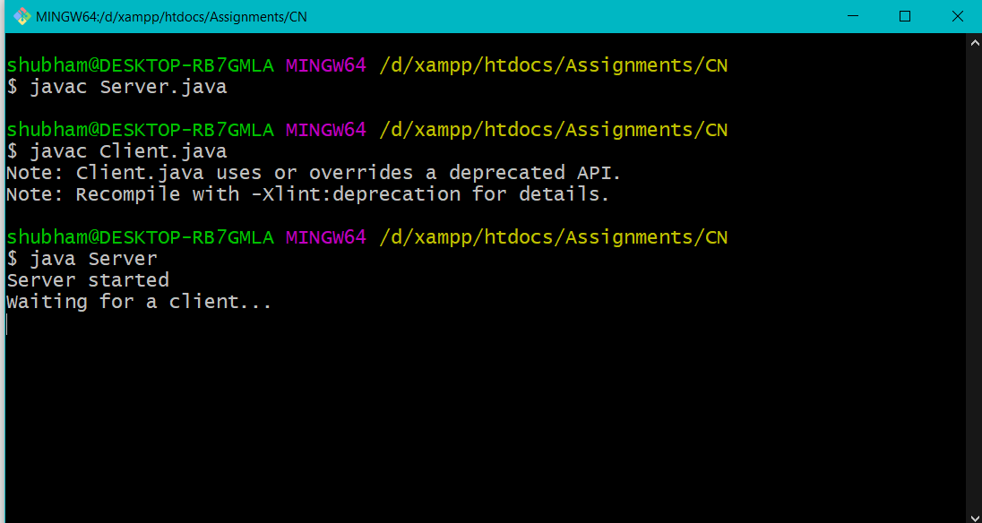

While Compiling Server.java and at a run time It will show.

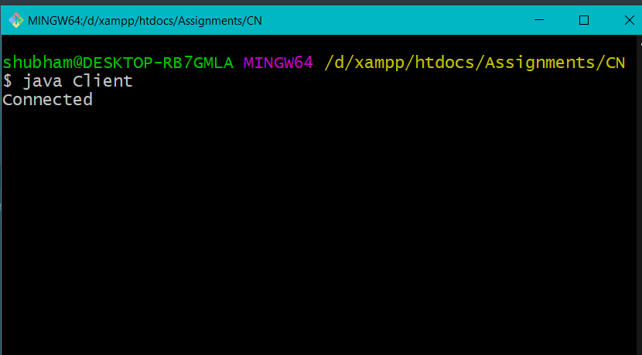

At a Time of Connection Sever Also Show Us Client Connected Message

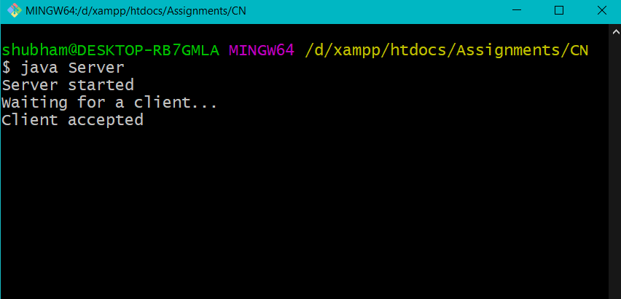

And Whatever message will send through Client Server will receive and Show the message.

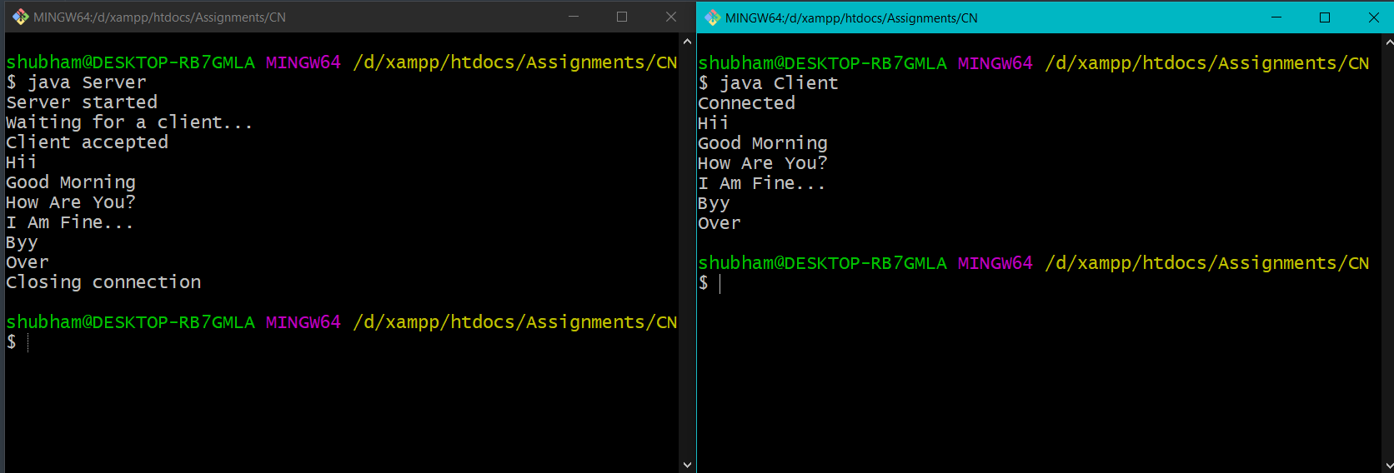

And “Over” Will Closing Connection Message at Server Side.